

CDE | Account Administration

User Accounts, Digital Certificates & LDAP

Version 1.0
January, 2002
Ken Emery
January, 2002Table of Contents
1 Key Concepts 3
1.1 Public Key Infrastructure (PKI) 3
1.2 Encryption/Decryption 3
1.3 Certificate Authority 3
1.4 Digital Signature 3
2 User Account Administration (LDAP) 4
2.1 LDAP 4
2.2 CareScience and LDAP 4
2.2.1 Authentication 4
2.2.2 Intersection Policy 4
2.2.3 Creating a User 4
3 User Certificates 8
3.1 Dev/Demo/Test User Certs 8
3.2 Production User Certs 10
4 Server Certificates 11
5 Reissuing Certificates 12

Key Concepts

Public Key Infrastructure (PKI)
A PKI enables users of a basically unsecure public network (such as the Internet) to securely and privately exchange data and money. This exchange is accomplished through the use of a public and a private cryptographic key pair that is obtained and shared through a trusted authority. One of the elements of a PKI is verifying the credentials of a certificate requestor through a Registration Authority (RA). CareScience is relying on the establishment of a business relationship with various entities as sufficient validity.
Public Key cryptography facilitates the following tasks:
- Encryption and decryption allow two communicating parties to disguise information they send to each other. The sender encrypts, or scrambles, information before sending it. The receiver decrypts, or unscrambles, the information after receiving it. While in transit, the encrypted information is unintelligible to an intruder.
- Tamper detection allows the recipient of information to verify that it has not been modified in transit. Any attempt to modify data or substitute a false message for a legitimate one will be detected.
- Authentication allows the recipient of information to determine its origin—that is, to confirm the sender’s identity.
- Nonrepudiation prevents the sender of information from claiming at a later date that the information was never sent.

Encryption/Decryption
A user’s or server’s public key is published and available to all and allows one entity to encrypt a transmission to another entity. The private key allows an entity to decrypt messages and is held only by the owner of that key.

Certificate Authority
A certificate authority (CA) is an authority in a network that issues and manages security credentials and public keys for message encryption.

For CDE, CareScience is acting as the Certificate Authority. Since CareScience is not one of the generally accepted Certificate Authorities, one of the steps in issuing server certificates is to add CareScience to the servers “list” of trusted Certificate Authorities.

Digital Signature
A digital signature “signs” the data that is transmitted so that 2 things can be verified. The first is that the data arrived exactly as sent. If one character is changed from the original, it will be known. The second verification is the identity of the sender. A hashing algorithm is used to digitally sign data.

User Account Administration (LDAP)

LDAP
User accounts are stored in an LDAP (Lightweight Directory Access Protocol) v.3 Directory. LDAP is a standard directory schema that is interoperable between many third-party products. Java has standard classes for interfacing with Java. The standard LDAP hierarchy organizes directories by the root, which branches out to countries, which branches out to organizations which branches out to organization units.

CareScience and LDAP

Authentication
A user’s credentials (username and password) are stored in the LDAP directory and accessed by the CDE frontend at signon. Additionally, the following information is stored on the certificate and MUST match the directory or access will be denied:
- Organization
- Organization Unit
- Email address

Intersection Policy
The organization stored in LDAP must be an organization to which a patient has been. If the patient has been to the user’s organization, then the user is permitted to see all of the patient’s records. If not, they are not permitted to see any of the patients records. The organization that is stored with the patient records is taken from the message header of the HL7 message sent to ICS.

Creating a User

- The account administrator must install the Netscape Console program. This is available as part of the Certificate Management System suite and can be installed without installing the full Certificate Management System.

- Access development/test/demo LDAP server (to create an account that will work on https://dev.carescience.com, https://democde.carescience.com and https://testcde.carescience.com):
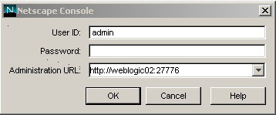
See Ken Emery, Arlan Pope, Tim Kwan or Karl Fankhauser for the Password.

- Access production LDAP server:
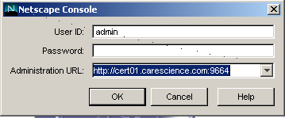
See Ken Emery or Tim Kwan for the password.

- Expand menus on left and double click on Directory Server as highlighted below:
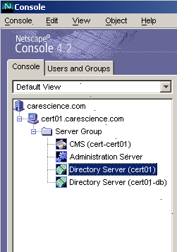

- Click on the Directory tab and expand carescience.com, which is our “root” or our “base dn”.
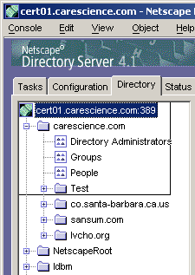

- To Create a new Organization, right mouse click on carescience.com and select New… Other… and select organization in the New object window.
Here are the current Organizations and Organization Units:
Customer | Organization | Organization Unit(s)
Cottage | sbch.org | cde.sbch.org
Lompoc | lvcho.org | webgateway.lvcho.org
Midcoast IPA | unilab.com | midcoast.unilab.com
Public Health | co.santa-barbara.ca.us | ccawebgateway.co.santa-barbara.ca.us
Sansum | sansum.com | santabarbara.sansum.com
SBRHA | sbrha.org | cde.sbrha.org
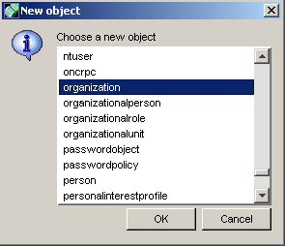
Note: the organization name must be carefully identified so as to be unique (the client’s domain name) and also exact as it is used to match the organization on the message header for the intersection policy.

- To Create a new Organization Unit, right mouse click on the Organization name (e.g. lvcho.org) and select New… Organization Unit.

- To Create a new User, right mouse click on the Organization Unit (e.g. webgateway.lvcho.org) and select New… User.
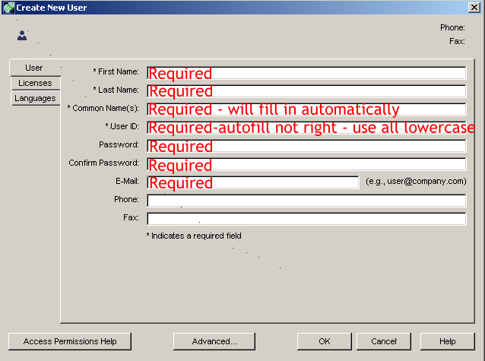
Note: User ID’s must be unique. The system will tell you if it is not and will not allow you to save a duplicate ID. E-Mail must be unique as well but the system does not verify this.

- In order to support Patient Lists being stored in LDAP, an ACI needs to be created. You create this by going under Advanced…, View…, Show All Attributes…, Click on ACI and choose “Add Value” and put the following in the value replacing the bold items with values for that user account:
For Dev/Test/Demo
(target="ldap:///uid=dev_care,ou=CDE,o=care.com,o=carescience.com")(targetattr="*")(version 3.0; acl "PatientListMediator"; allow (all) userdn = "ldap:///uid=testuser, ou=People, o=carescience.com"; )
For Prod
(target="ldap:///uid=dev_care,ou=CDE,o=care.com,o=carescience.com")(targetattr="*")(version 3.0; acl "PatientListMediator"; allow (all) userdn = "ldap:///uid=produser, ou=People, o=carescience.com"; )

User Certificates

Dev/Demo/Test User Certs
These environments are using Manual Enrollment. This can be done by going to http://weblogic02:7001 and filling in the following:

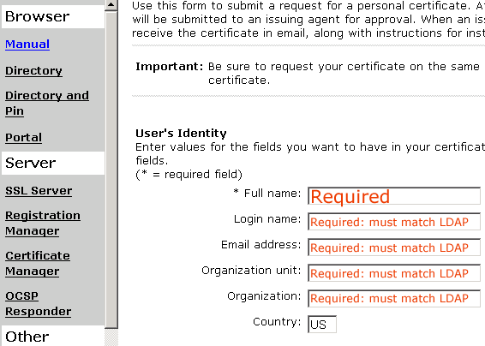
Either the end user must fill out the form above or the Administrator can do this, import the certificate themselves and then export the certificate (including the private key) and send it to the person to import providing the following instructions for import.

- Detach file to your PC
- Go into Internet Explorer
- Click Tools... Internet Options... Content... Certificates...
- Click Import
- Click "Next"
- Browse and find the file <replace this with export filename>.pfx
- Click "Open"
- Click "Next"
- Check "Mark private key as exportable"
- Make sure "Enable strong..." is unchecked
- Enter "<replace this with private keystore password set on exporting>" into "Password"
- Click Next
- Leave "Automatically..." selected and click "Next"
- Click "Finish"
- You should get a message "Successfully Imported"
- Back out of all the screens and try https://testcde.carescience.com
ID: <replace this with user id from LDAP>
Pass: <replace this with password from LDAP>

To approve the certificate the Administrator must have the administrator certificate loaded in their browser (the Cert is named Arlan Pope and can be acquired from Ken Emery or Arlan Pope). Go to the address https://weblogic02:8100 and choose “List Requests”. Scroll down and select “SHA1 with RSA” and then approve the request. Go back to http://weblogic02:7001 and click on the “Retrieval” tab. On this page enter the request #. Right mouse click on the link to the certificate and select “Open link in new window”. Cut the url out of the newly opened browser and send it to the user instructing them to go to the link and select “Import” at the bottom of the screen.
The password change url for dev/test/demo is http://dev.carescience.com/cdepass/.

Production User Certs
Production certs use the PIN based method of enrollment. The reason is so that users or Local Admins can retrieve the certificates multiple times for different workstations. This is the way Santa Barbara will operate. Note that with all user certificates that a user must use their certificate or their access will be denied (it matches certificate information to their LDAP entry). So, even if there are other certs on a machine for CDE, you can only use your own cert.

How the PIN method of enrollment is accomplished:

- Entering the user in the LDAP directory.
- Running the PIN tool on the server (this, unfortunately, is a bit of a kluge in that it only runs at the command prompt of the LDAP server). Here is the PIN command used to generate the second set of production PINs:
setpin host=cert01 port=389 "binddn=CN=Directory Manager" bindpw=sciencecare basedn=o=carescience.com output=testpin2.txt filter=(uid=*) write case=upperonly
Run this on cert01 in the directory C:\Netscape\Server4\bin\cert\tools. You can use VNC to access cert01 – see Ken Emery or Tim Kwan for the password.
This creates a file called “testpin2.txt” that houses all of the PIN #’s for the ID’s in the directory. It forces the PIN’s to be all upper case. It will not overwrite existing PIN numbers (there is an option to do this that I don’t want to mention because it probably shouldn’t ever be done – if it was, we’d have to re-distribute PIN numbers that have already gone out). You can specify specific user id’s instead of * if desired. I didn’t have any luck specifying “o=” and “ou=” but it is part of the syntax.
- The end user gets their ID, Password and PIN out-of-band (email, snail mail, from their LocalAdmin etc.) and then does the following:
- Go to http://cert.carescience.com/
- Click on "Directory and Pin" in the left navigation frame
- Enter User ID, Password and PIN for user
- Select the strongest encryption available out of these three:
- Microsoft Base Cryptographic Provider v1.0 (Strong)
- Microsoft Enhanced Cryptographic Provider v1.0 (Stronger)
- Microsoft Strong Cryptographic Provider v1.0 (Strongest)
- Hit "Submit"
- You should get a confirmation that the Certificate was successfully imported.

Note: When many certs are on one PC there will be a selection list that shows the first and last name of the cert owner. So, it should be easy for users to identify their own cert.
To Change Password

- The URL will most likely be: https://apps.carescience.com/cdepass/edit.cgi?userpasswd but I don't have a confirmation on that yet.

- So how does this work? Normally certificates go through a request/approval process and will only work on the PC the requester requested it from. Well, the entry into LDAP and the possession of the ID, Password and PIN are considered to be pre-approval. So the entry of the ID, Password and PIN into the site communicates a machine thumbprint to the cert server and a cert is requested and imported in response.

Server Certificates
Server certificates accomplish several things including:
- creating a private keystore and private key
- making CareScience a trusted Certificate Authority in the private keystore as well as in the Java trusted certs file
- requesting/signing/importing of the signed public key.

There are a couple ways to do this. The first is to use the Certificate Wizard that is available from http://www.carescience.com/downloads/index.htm or to use the manual steps as identified in http://documents.carescience.com/CDE/TechnicalDocuments/CareScienceProdServerCertInstructions.html.

Once a .csr file has been created and sent, go to http://weblogic02:7001 for dev/test/demo or http://cert.carescience.com for prod and click on SSL Server. Paste the contents of their request from the “---BEGIN…” to “---END…” (including any non-visible characters on the same line as “---END…” but no characters on the next line). Fill out the other pieces of info. and submit. Then go to https://weblogic02:8100 for dev/test/demo and https://cert.carescience.com:8100 for prod. List requests. Scroll down and make sure all uses (including client) are approved. Make sure SHA1 is selected. Approve the certificate. Cut and paste the contents listed after the “64 byte encoding” into a file <name of client>-cert.cer and get it to the client. Although we have sent via snail mail as this is only a public key.
The client then follows the last step on the manual instructions of uses the Certificate Wizard to import the signed cert.

Reissuing Certificates

As of now, the policy as set forth by Lori for the community is to issue server certificates for 2 years and user certificates for one year. In order for the system to keep working, certificates need to be re-issued prior to the expiration date. For users, this will probably just mean going to the PIN site and re-retrieving a certificate. For server certs I’m not sure that the process is. I think we’ll need to contact the end entity and let them know their cert is about to expire and have them re-request. Right now everyone’s server certs expire in 1 year even though the policy is 2 years because the default Certificate Management System setting is to only allow 1 year so you can’t create a 2 year. Hopefully I can change this to allow up to 2 years.

The CA certificate for CareScience doesn’t expire until 9/3/2034. The Dev/Test/Demo CA certificate expires on 2/14/2003.

Ken E currently checks monthly for expiring certificates per below:

